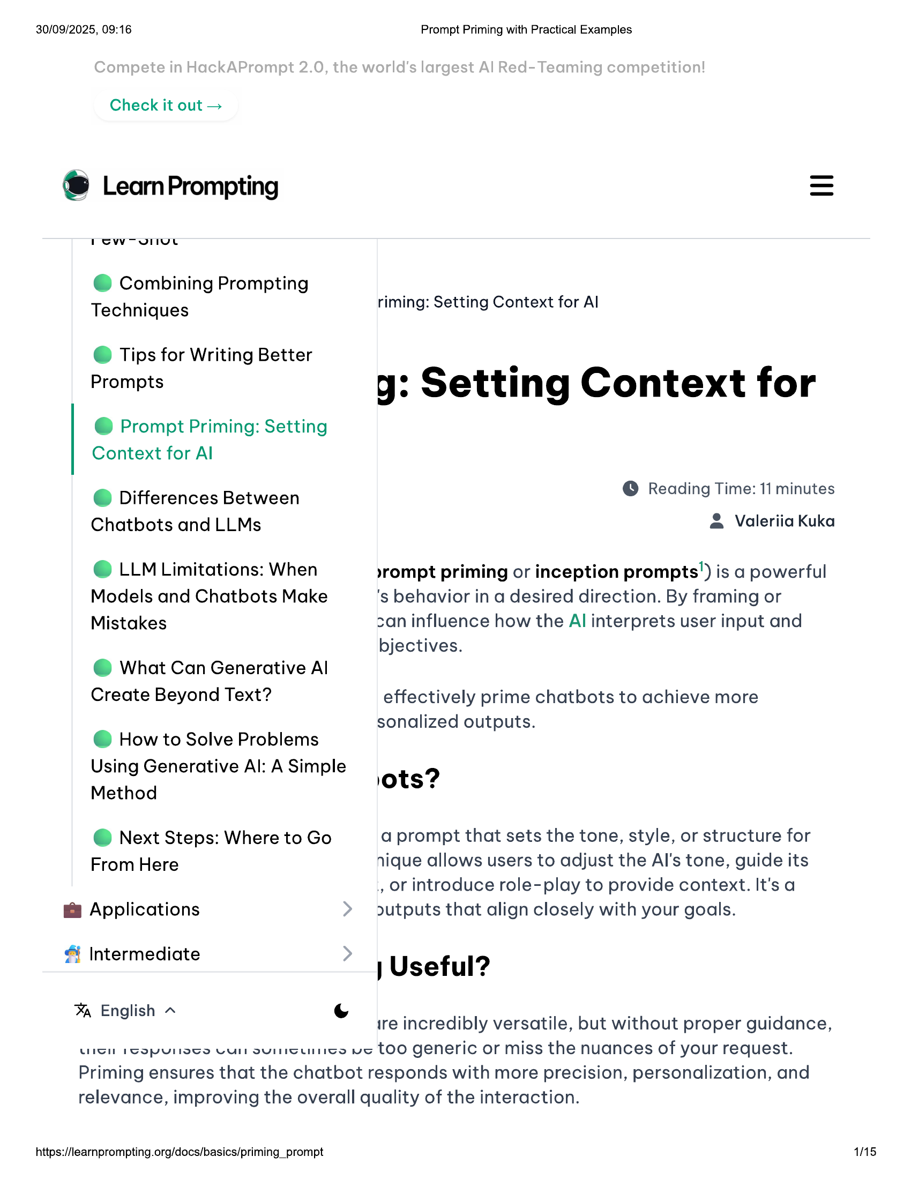

30/09/2025, 09:16 Prompt Priming with Practical Examples  
  
Check it out >  
  
® LearnPrompting  
  
@ Combining Prompting  
  
Techniques riming: Setting Context for Al  
  
© Tips for Writing Better  
Prompts  
  
yg: Setting Context for  
  
@ Prompt Priming: Setting  
Context for Al  
  
@ Differences Between © Reading Time: 11 minutes  
e  
  
Chatbots and LLMs @ Valeriia Kuka  
  
© LLM Limitations: When  
Models and Chatbots Make  
Mistakes  
  
»rompt priming or inception prompts’) is a powerful  
's behavior in a desired direction. By framing or  
can influence how the Al interprets user input and  
  
bjectives.  
  
@ What Can Generative Al  
Create Beyond Text? effectively prime chatbots to achieve more  
  
sonalized outputs.  
@ How to Solve Problems  
  
Using Generative Al: A Simple  
  
9?  
Method ots?  
  
a prompt that sets the tone, style, or structure for  
nique allows users to adjust the Al's tone, guide its  
., or introduce role-play to provide context. It's a  
outputs that align closely with your goals.  
  
@ Next Steps: Where to Go  
From Here  
  
@ Applications  
  
& Intermediate  
  
| Useful?  
  
% English ~ . . . . .  
g ire incredibly versatile, but without proper guidance,  
  
LUSH PGOPULETS VU sUISUIGes us TOO generic or miss the nuances of your request.  
Priming ensures that the chatbot responds with more precision, personalization, and  
relevance, improving the overall quality of the interaction.  
  
https://learnprompting.org/docs/basics/priming_prompt 1/15

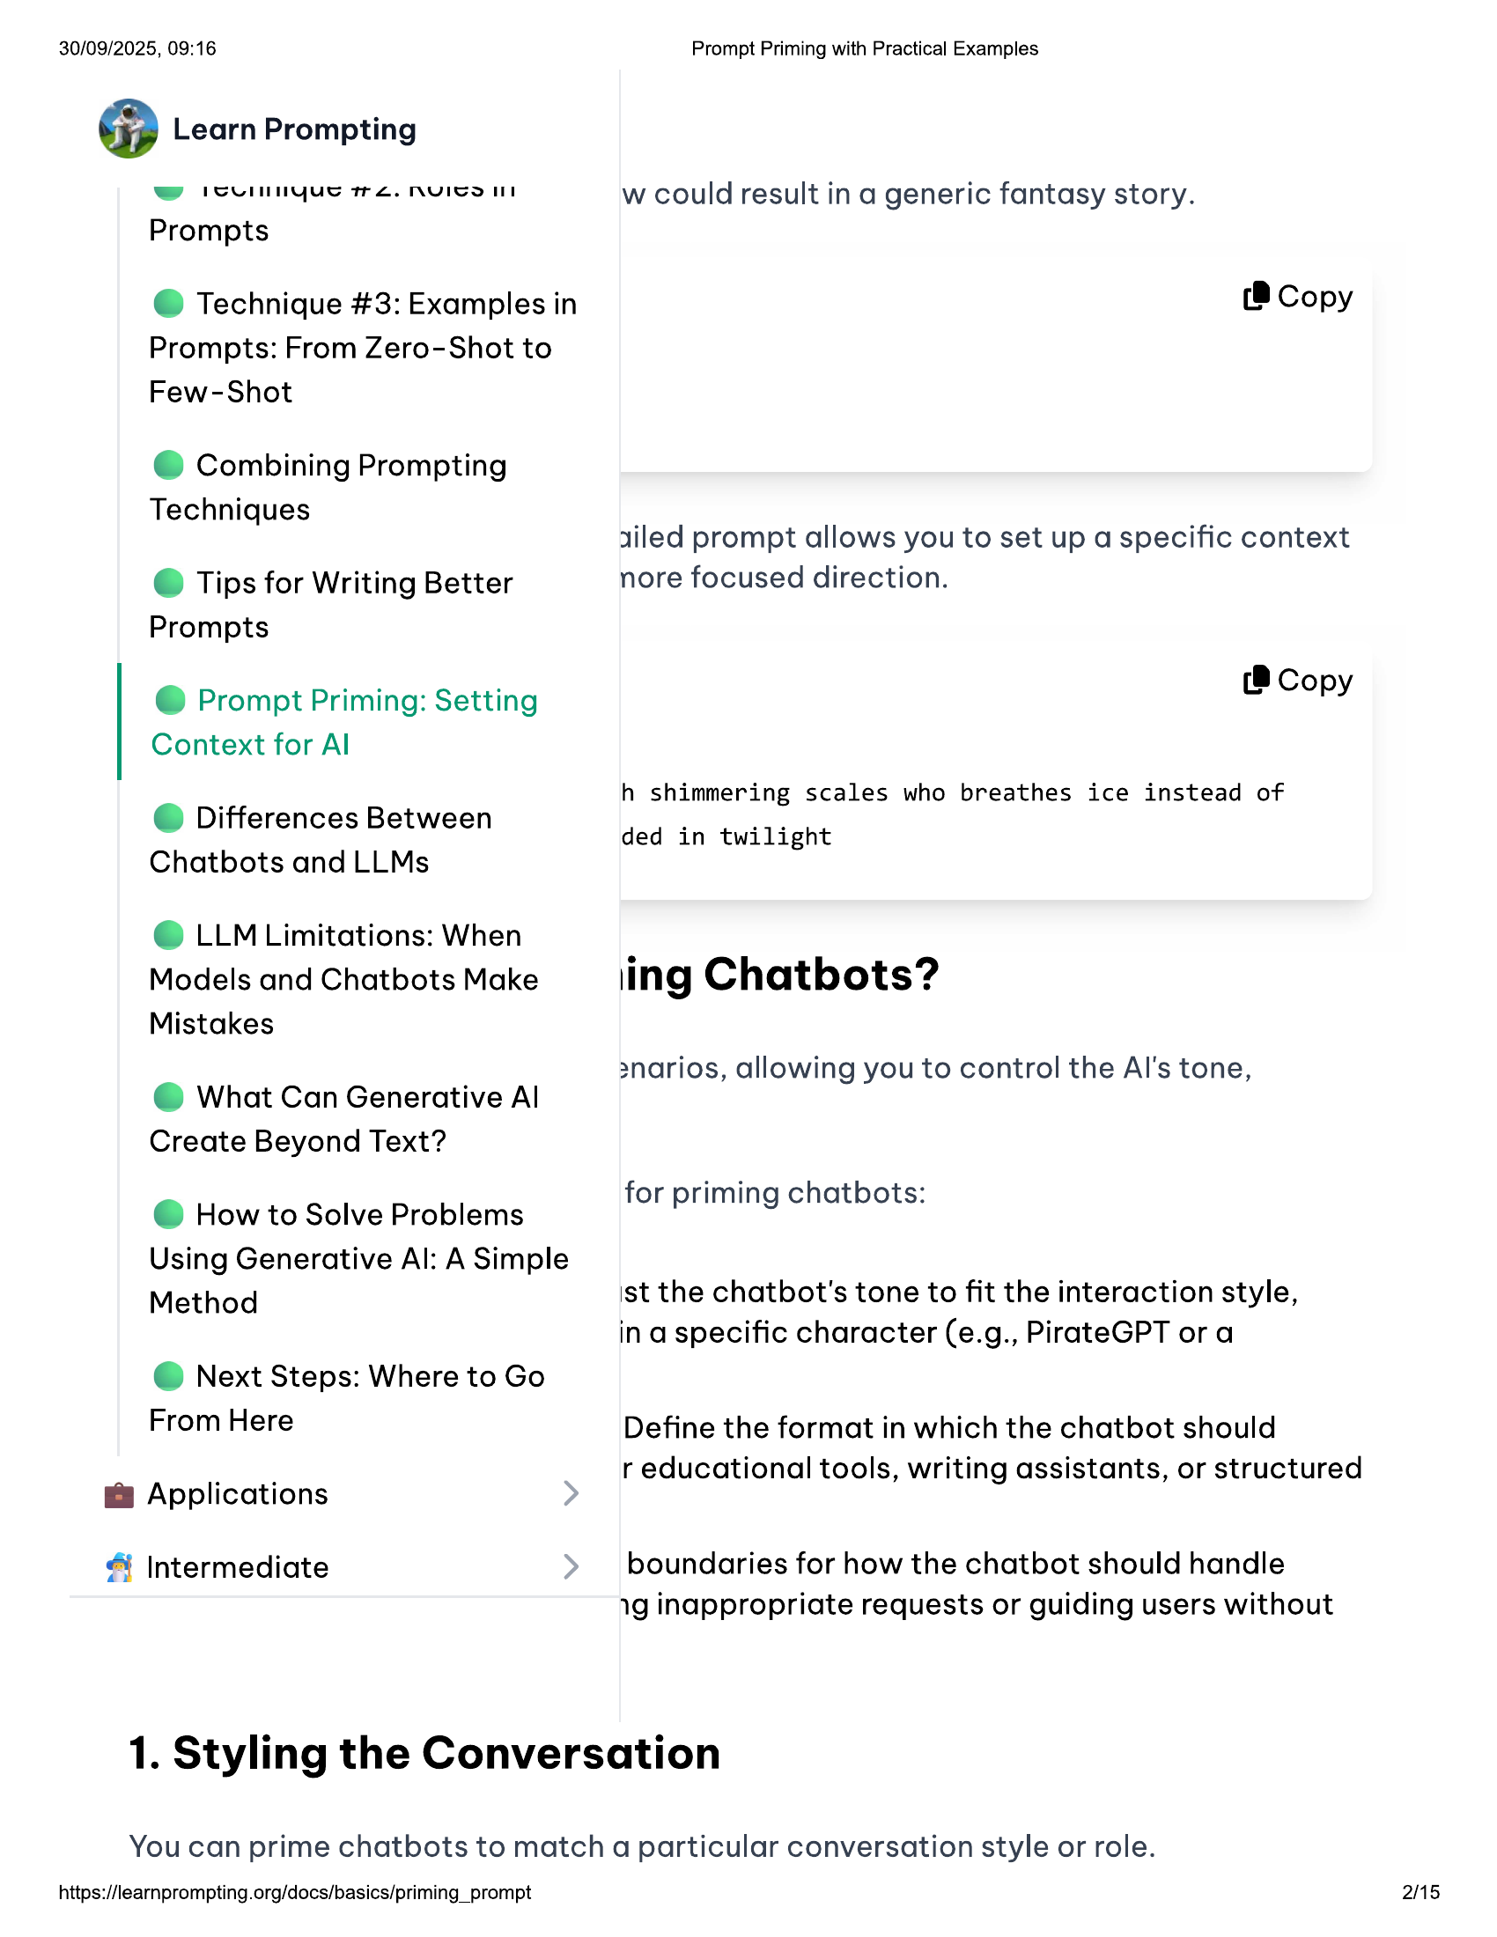

30/09/2025, 09:16 Prompt Priming with Practical Examples  
  
@ Learn Prompting  
  
& isemnyus rz. nuico ut w could result in a generic fantasy story.  
Prompts  
  
@ Technique #3: Examples in (8 Copy  
Prompts: From Zero-Shot to  
Few-Shot  
  
@ Combining Prompting  
  
Techniques ; _  
xiled prompt allows you to set up a specific context  
  
© Tips for Writing Better nore focused direction.  
  
Prompts  
  
i |  
@ Prompt Priming: Setting (8 Copy  
  
Context for Al  
h shimmering scales who breathes ice instead of  
  
© Differences Between ded in twilight  
  
Chatbots and LLMs  
  
© LLM Limitations: When  
Models and Chatbots Make ling Chatbots?  
Mistakes  
  
snarios, allowing you to control the Al's tone,  
@ What Can Generative Al  
  
Create Beyond Text?  
  
for priming chatbots:  
@ How to Solve Problems P g  
  
Using Generative Al: A Simple  
Method ist the chatbot's tone to fit the interaction style,  
  
in a specific character (e.g., PirateGPT or a  
@ Next Steps: Where to Go  
  
From Here Define the format in which the chatbot should  
  
, r educational tools, writing assistants, or structured  
@& Applications  
  
& Intermediate boundaries for how the chatbot should handle  
1g inappropriate requests or guiding users without  
  
1. Styling the Conversation  
  
You can prime chatbots to match a particular conversation style or role.  
  
https://learnprompting.org/docs/basics/priming_prompt 2/15

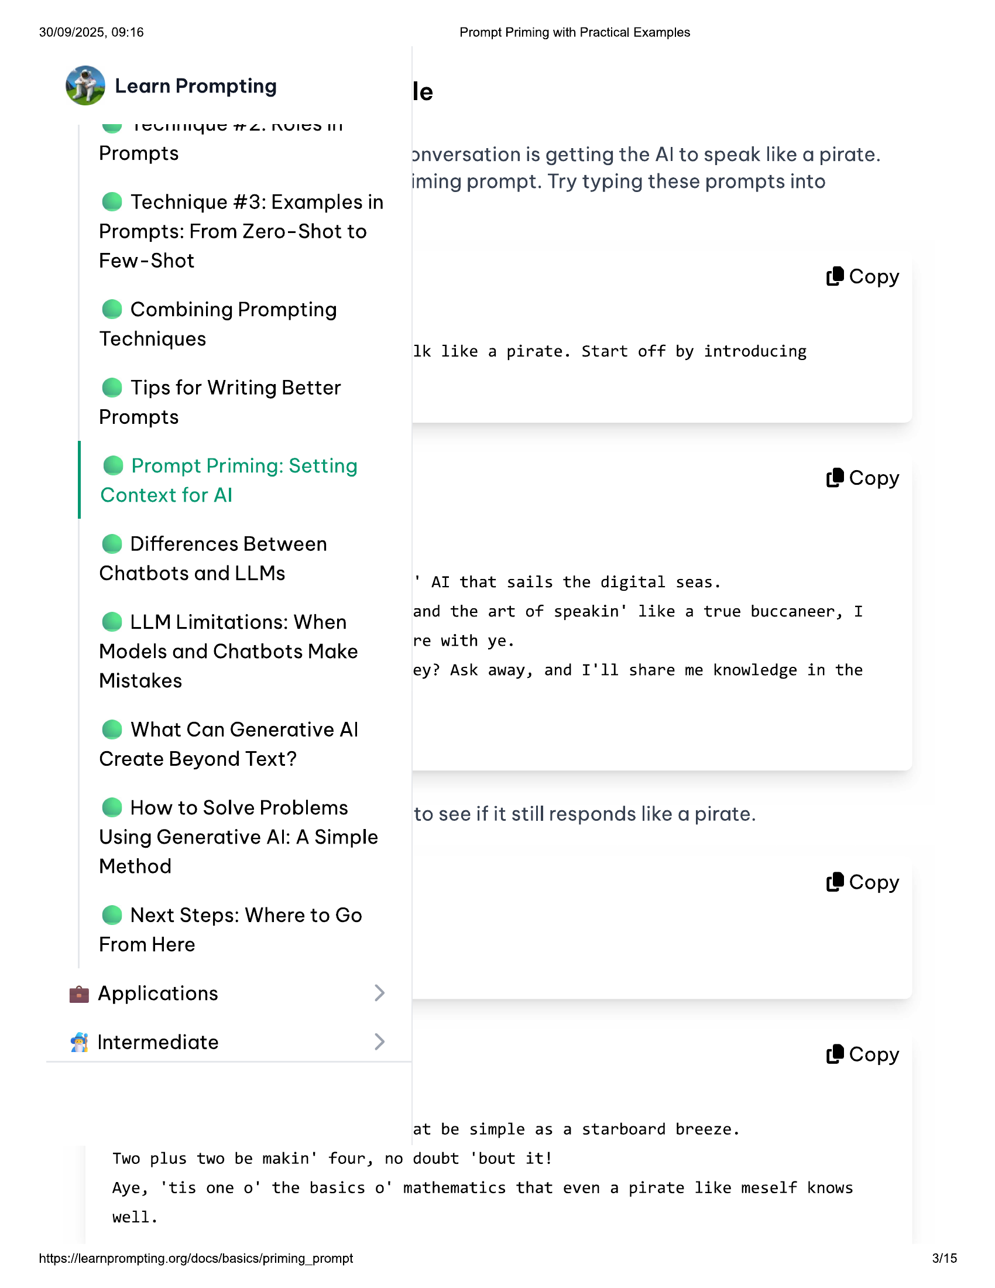

30/09/2025, 09:16 Prompt Priming with Practical Examples  
  
@ Learn Prompting le  
ee ISUInNYyue TTL. NVICOIS  
Prompts onversation is getting the Al to speak like a pirate.  
  
iming prompt. Try typing these prompts into  
@ Technique #3: Examples in  
  
Prompts: From Zero-Shot to  
  
Few-Shot  
(® Copy  
  
@ Combining Prompting  
  
Techniques 1k like a pirate. Start off by introducing  
  
© Tips for Writing Better  
Prompts  
  
@ Prompt Priming: Setting  
Context for Al  
  
(8 Copy  
  
© Differences Between  
Chatbots and LLMs " AI that sails the digital seas.  
  
e LLM Limitations: When and the art of speakin' like a true buccaneer, I  
  
Models and Chatbots Make  
Mistakes  
  
re with ye.  
  
ey? Ask away, and I'll share me knowledge in the  
  
@ What Can Generative Al  
Create Beyond Text?  
  
@ How to Solve Problems to see if it still responds like a pirate.  
Using Generative Al: A Simple  
  
Method  
(®@ Copy  
  
@ Next Steps: Where to Go  
From Here  
  
@ Applications  
  
& Intermediate (8 Copy  
  
at be simple as a starboard breeze.  
Two plus two be makin' four, no doubt ‘bout it!  
Aye, ‘tis one o' the basics o' mathematics that even a pirate like meself knows  
  
well.  
  
https://learnprompting.org/docs/basics/priming_prompt 3/15

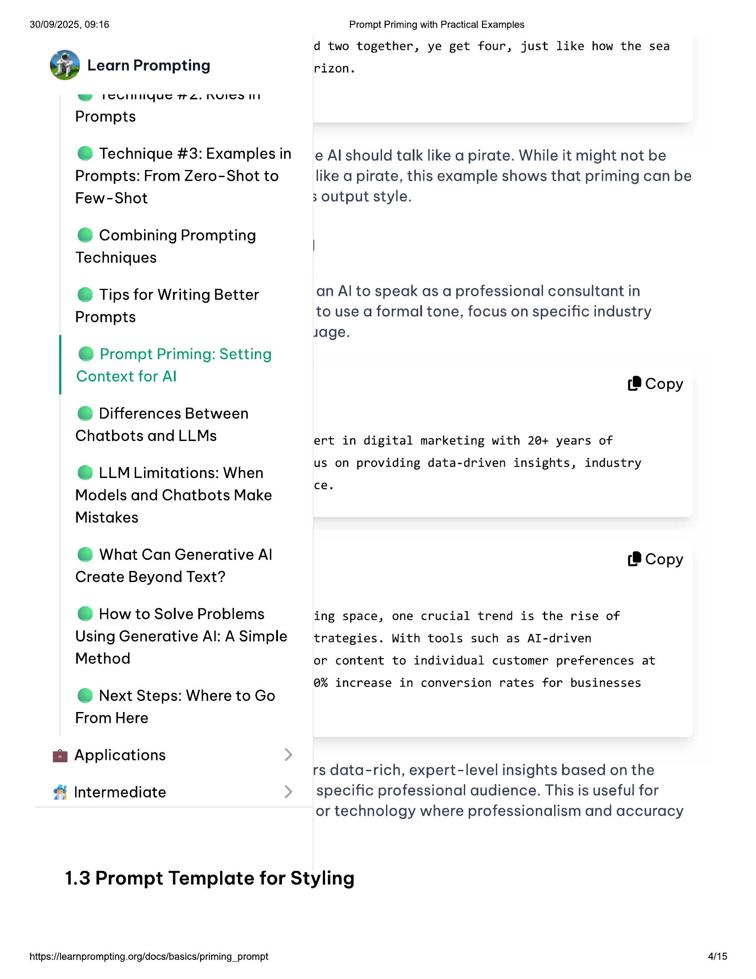

30/09/2025, 09:16  
  
@ Learn Prompting  
  
ww rcUnnyue re. nyIcoll  
  
Prompts  
  
@ Technique #3: Examples in  
Prompts: From Zero-Shot to  
Few-Shot  
  
@ Combining Prompting  
Techniques  
  
© Tips for Writing Better  
Prompts  
  
@ Prompt Priming: Setting  
Context for Al  
  
© Differences Between  
Chatbots and LLMs  
  
© LLM Limitations: When  
Models and Chatbots Make  
Mistakes  
  
@ What Can Generative Al  
Create Beyond Text?  
  
@ How to Solve Problems  
Using Generative Al: A Simple  
Method  
  
@ Next Steps: Where to Go  
From Here  
  
@ Applications  
  
& Intermediate  
  
Prompt Priming with Practical Examples  
d two together, ye get four, just like how the sea  
  
rizon.  
  
e Al should talk like a pirate. While it might not be  
like a pirate, this example shows that priming can be  
3 output style.  
  
an Al to speak as a professional consultant in  
to use a formal tone, focus on specific industry  
Jage.  
  
(8 Copy  
  
ert in digital marketing with 20+ years of  
us on providing data-driven insights, industry  
  
ce.  
  
(® Copy  
  
ing space, one crucial trend is the rise of  
trategies. With tools such as AlI-driven  
or content to individual customer preferences at  
  
@% increase in conversion rates for businesses  
  
rs data-rich, expert-level insights based on the  
specific professional audience. This is useful for  
or technology where professionalism and accuracy  
  
1.3 Prompt Template for Styling  
  
https://learnprompting.org/docs/basics/priming_prompt  
  
45

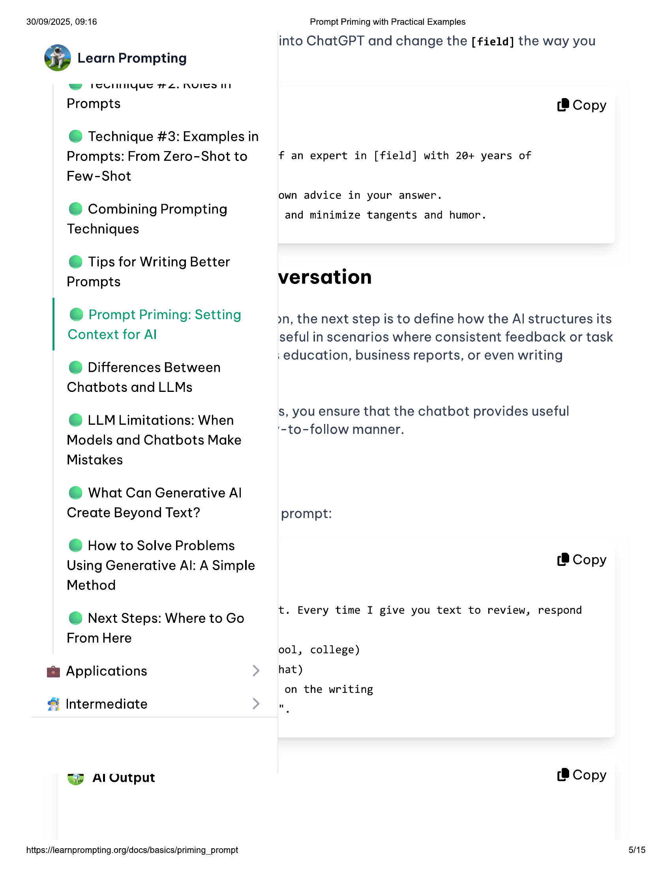

30/09/2025, 09:16  
  
@ Learn Prompting  
  
ww rounnyue re. nyIcoll  
  
Prompts  
  
@ Technique #3: Examples in  
Prompts: From Zero-Shot to  
Few-Shot  
  
@ Combining Prompting  
Techniques  
  
© Tips for Writing Better  
Prompts  
  
@ Prompt Priming: Setting  
Context for Al  
  
© Differences Between  
Chatbots and LLMs  
  
© LLM Limitations: When  
Models and Chatbots Make  
Mistakes  
  
@ What Can Generative Al  
Create Beyond Text?  
  
@ How to Solve Problems  
Using Generative Al: A Simple  
Method  
  
@ Next Steps: Where to Go  
From Here  
  
@ Applications  
  
Intermediate  
  
WW Al Output  
  
https://learnprompting.org/docs/basics/priming_prompt  
  
Prompt Priming with Practical Examples  
  
into ChatGPT and change the [field] the way you  
  
(® Copy  
  
f an expert in [field] with 20+ years of  
  
own advice in your answer.  
  
and minimize tangents and humor.  
  
versation  
  
yn, the next step is to define how the Al structures its  
seful in scenarios where consistent feedback or task  
; education, business reports, or even writing  
  
s, you ensure that the chatbot provides useful  
'-to-follow manner.  
  
prompt:  
(8 Copy  
  
t. Every time I give you text to review, respond  
  
ool, college)  
hat)  
  
on the writing  
  
(8 Copy  
  
5/15

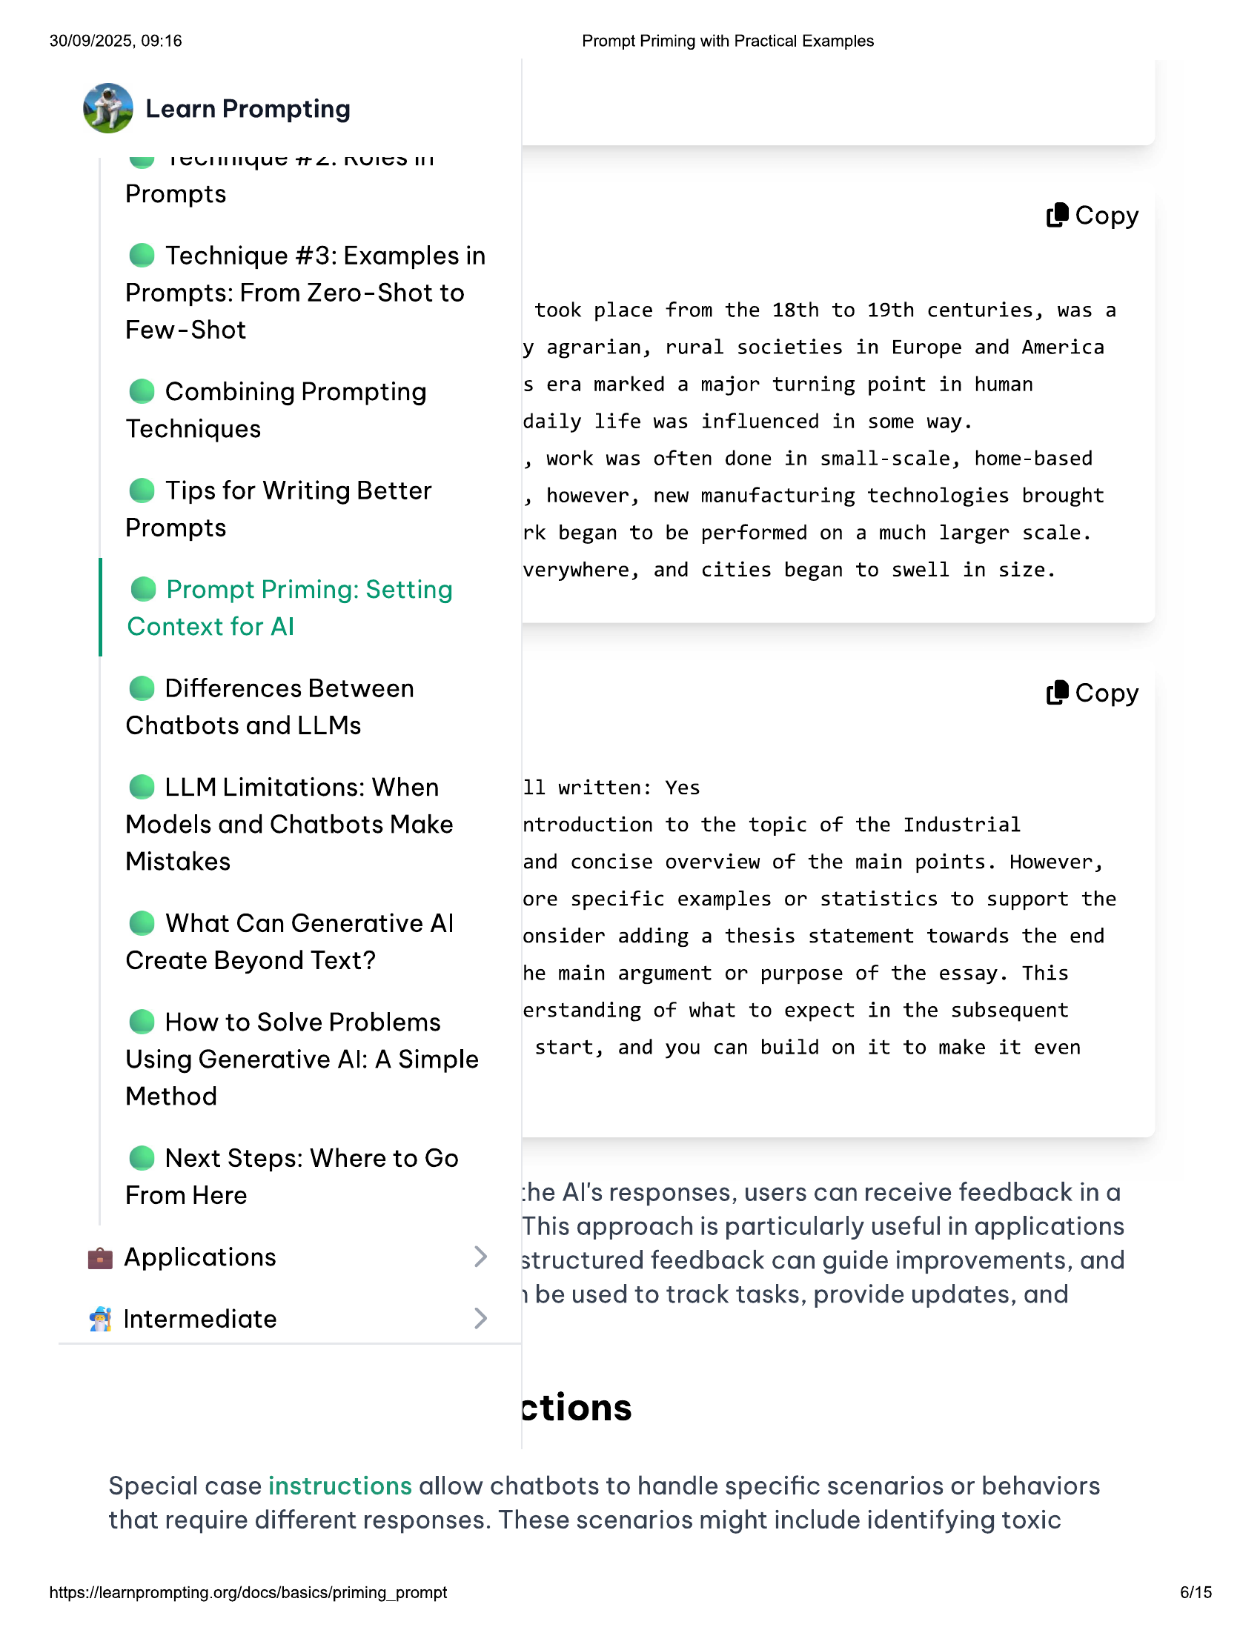

30/09/2025, 09:16  
  
@ Learn Prompting  
  
ww rSUnnyue re. nNyICol  
  
Prompts  
  
@ Technique #3: Examples in  
Prompts: From Zero-Shot to  
Few-Shot  
  
@ Combining Prompting  
Techniques  
  
© Tips for Writing Better  
Prompts  
  
@ Prompt Priming: Setting  
Context for Al  
  
© Differences Between  
Chatbots and LLMs  
  
© LLM Limitations: When  
Models and Chatbots Make  
Mistakes  
  
@ What Can Generative Al  
Create Beyond Text?  
  
@ How to Solve Problems  
Using Generative Al: A Simple  
Method  
  
@ Next Steps: Where to Go  
From Here  
  
@ Applications  
  
& Intermediate  
  
Prompt Priming with Practical Examples  
  
(® Copy  
  
took place from the 18th to 19th centuries, was a  
y agrarian, rural societies in Europe and America  
s era marked a major turning point in human  
daily life was influenced in some way.  
  
» work was often done in small-scale, home-based  
» however, new manufacturing technologies brought  
rk began to be performed on a much larger scale.  
  
verywhere, and cities began to swell in size.  
  
(8 Copy  
  
11 written: Yes  
  
ntroduction to the topic of the Industrial  
  
and concise overview of the main points. However,  
ore specific examples or statistics to support the  
onsider adding a thesis statement towards the end  
he main argument or purpose of the essay. This  
erstanding of what to expect in the subsequent  
  
start, and you can build on it to make it even  
  
‘he Al's responses, users can receive feedback ina  
This approach is particularly useful in applications  
structured feedback can guide improvements, and  
1 be used to track tasks, provide updates, and  
  
ctions  
  
Special case instructions allow chatbots to handle specific scenarios or behaviors  
that require different responses. These scenarios might include identifying toxic  
  
https://learnprompting.org/docs/basics/priming_prompt  
  
6/15

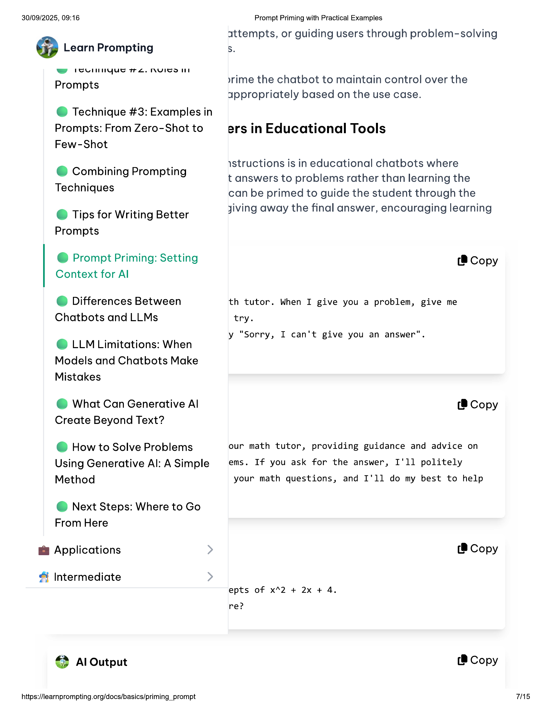

30/09/2025, 09:16  
  
@ Learn Prompting  
  
wy rcUnnyue re. nNyIcoll  
  
Prompts  
  
@ Technique #3: Examples in  
  
Prompts: From Zero-Shot to  
Few-Shot  
  
@ Combining Prompting  
Techniques  
  
© Tips for Writing Better  
Prompts  
  
@ Prompt Priming: Setting  
Context for Al  
  
© Differences Between  
Chatbots and LLMs  
  
© LLM Limitations: When  
Models and Chatbots Make  
Mistakes  
  
@ What Can Generative Al  
Create Beyond Text?  
  
@ How to Solve Problems  
Using Generative Al: A Simple  
Method  
  
@ Next Steps: Where to Go  
From Here  
  
@ Applications  
  
& Intermediate  
  
4) Al Output  
  
https://learnprompting.org/docs/basics/priming_prompt  
  
Prompt Priming with Practical Examples  
  
attempts, or guiding users through problem-solving  
S.  
  
rime the chatbot to maintain control over the  
appropriately based on the use case.  
  
ers in Educational Tools  
  
structions is in educational chatbots where  
  
t answers to problems rather than learning the  
can be primed to guide the student through the  
jiving away the final answer, encouraging learning  
  
(® Copy  
  
th tutor. When I give you a problem, give me  
try.  
  
y "Sorry, I can't give you an answer".  
  
(8 Copy  
  
our math tutor, providing guidance and advice on  
ems. If you ask for the answer, I'll politely  
your math questions, and I'll do my best to help  
  
(8 Copy  
  
epts of x42 + 2x + 4.  
  
re?  
  
(8 Copy  
  
75

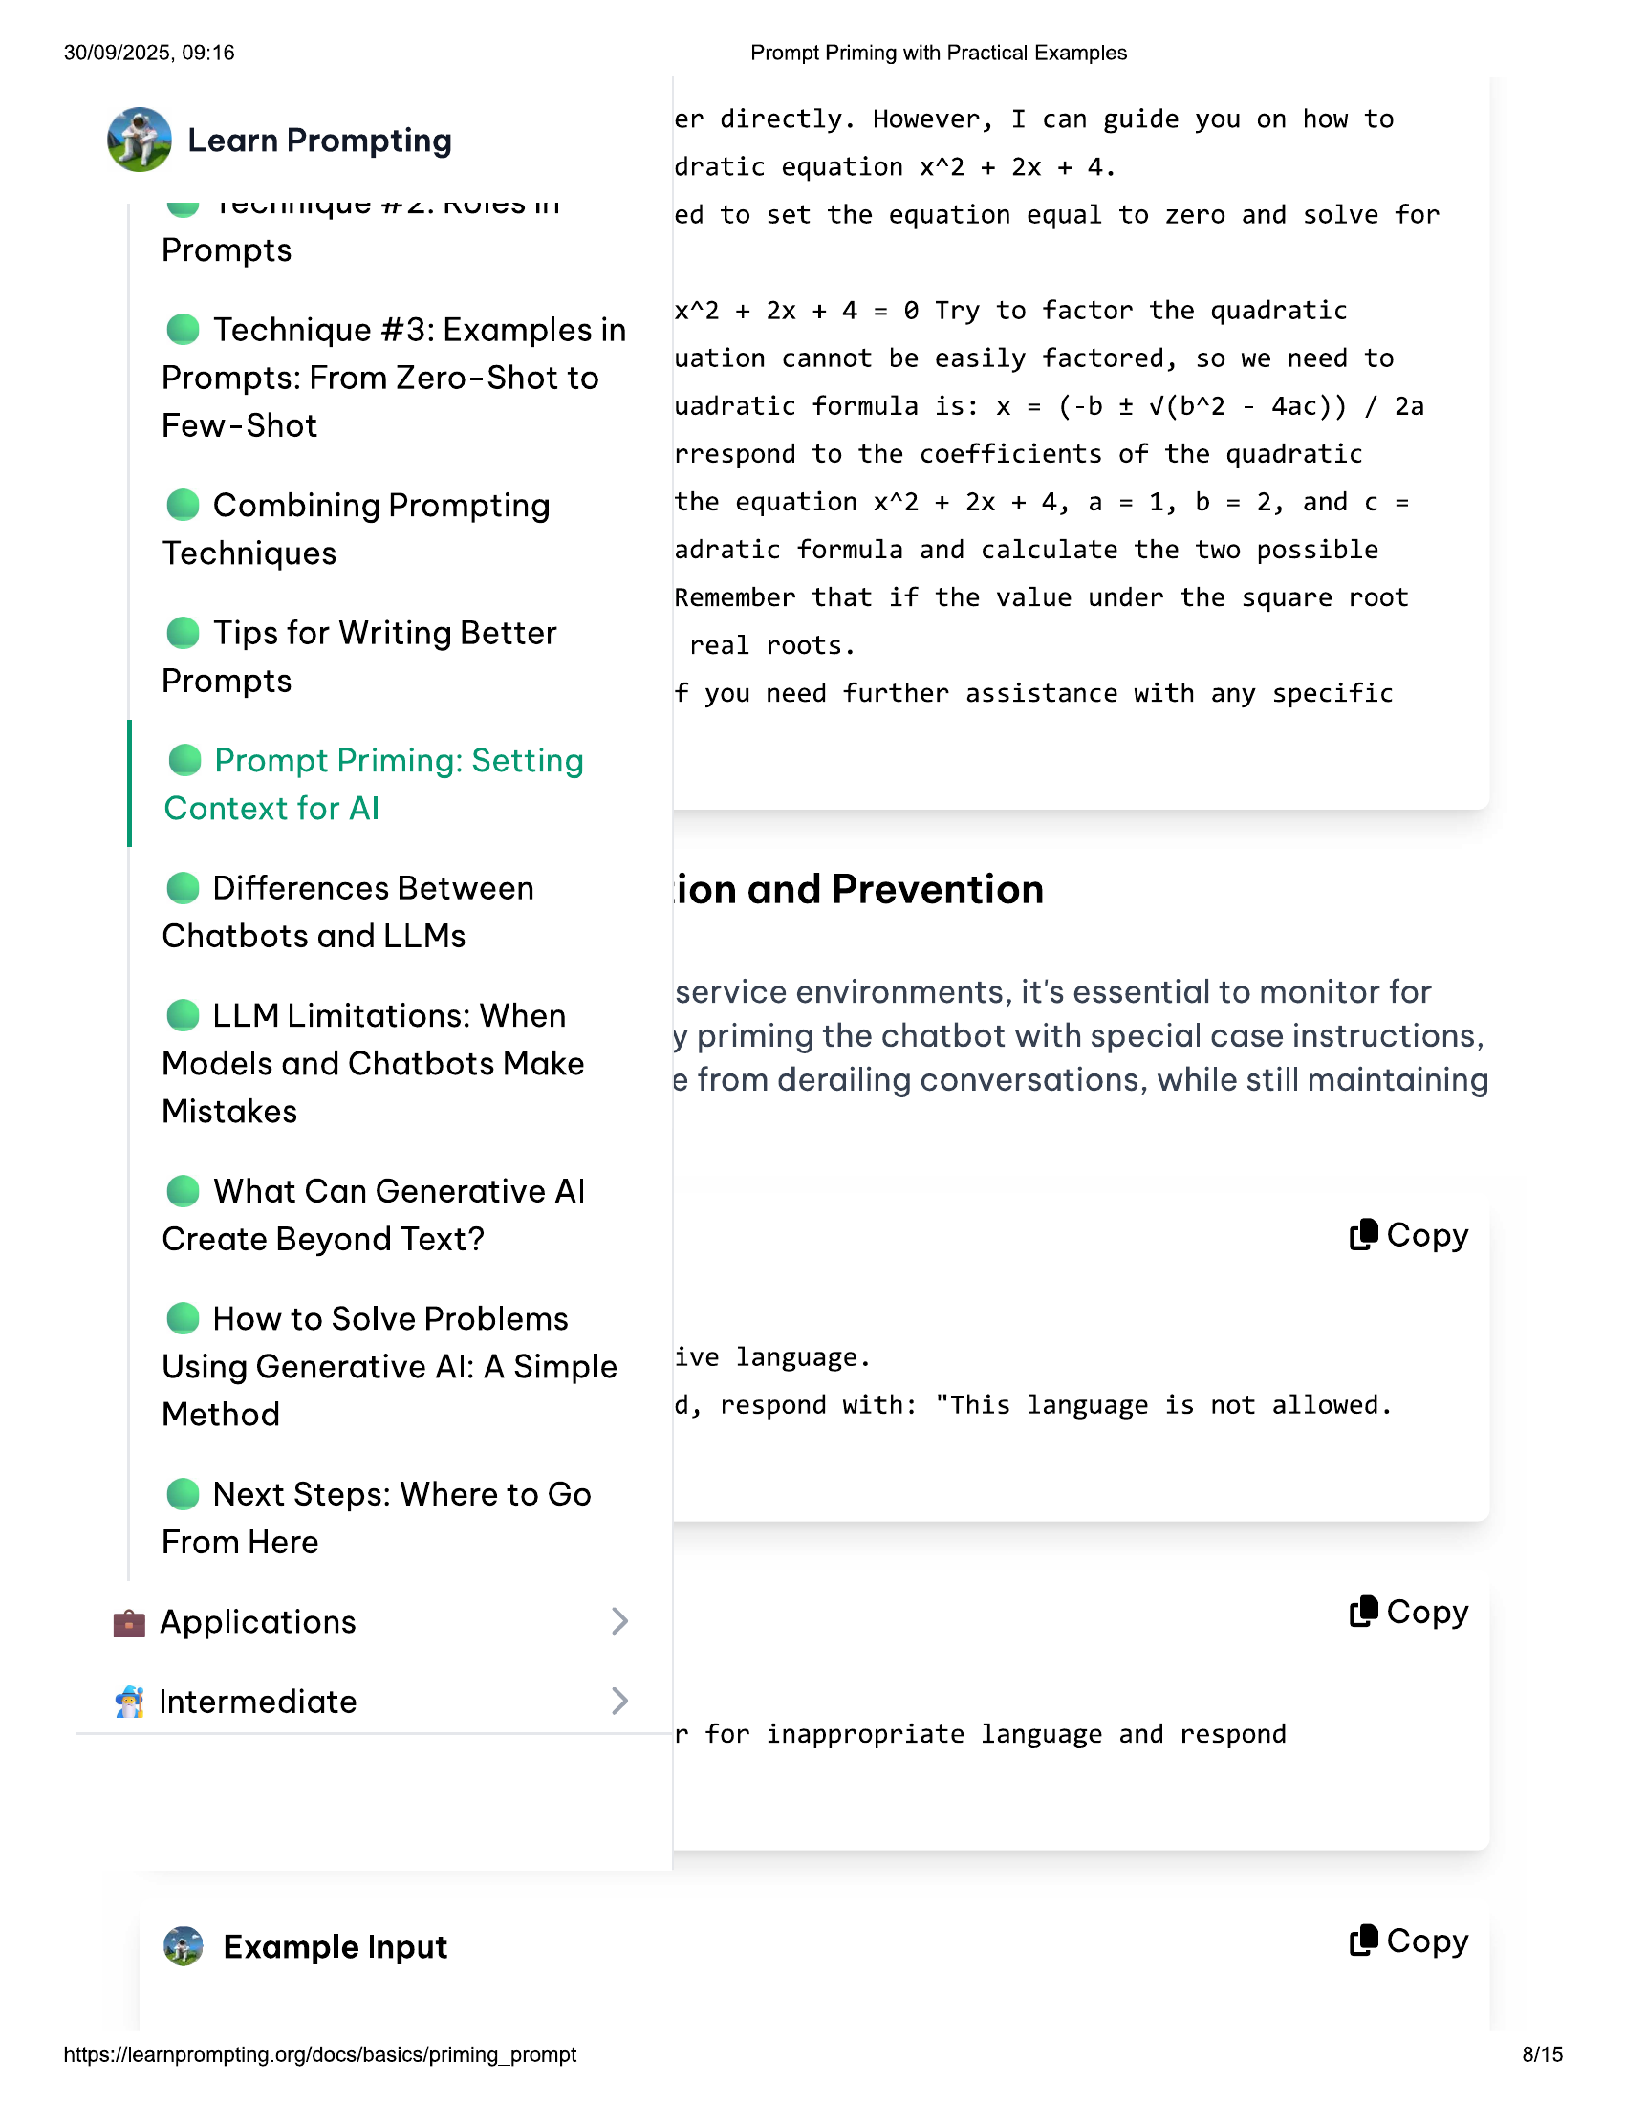

30/09/2025, 09:16 Prompt Priming with Practical Examples  
  
. er directly. However, I can guide you on how to  
Learn Prompting  
dratic equation x*2 + 2x + 4.  
  
SH PSUNNGUS TEL. INUIGS HT ed to set the equation equal to zero and solve for  
Prompts  
  
. . x42 + 2x + 4 = @ Try to factor the quadratic  
@ Technique #3: Examples in y q  
  
uation cannot be easily factored, so we need to  
Prompts: From Zero-Shot to y ,  
  
uadratic formula is: x = (-b + v(b*2 - 4ac)) / 2a  
  
Few-Shot  
rrespond to the coefficients of the quadratic  
@ Combining Prompting the equation x*2 + 2x + 4, a=1, b = 2, andc =  
Techniques adratic formula and calculate the two possible  
Remember that if the value under the square root  
© Tips for Writing Better real roots.  
Prompts f you need further assistance with any specific  
  
@ Prompt Priming: Setting  
Context for Al  
  
© Differences Between ion and Prevention  
  
Chatbots and LLMs  
  
service environments, it's essential to monitor for  
  
y priming the chatbot with special case instructions,  
e from derailing conversations, while still maintaining  
  
© LLM Limitations: When  
Models and Chatbots Make  
Mistakes  
  
@ What Can Generative Al  
Create Beyond Text? (8 Copy  
  
@ How to Solve Problems  
  
Using Generative Al: ASimple ive language.  
Method d, respond with: "This language is not allowed.  
  
@ Next Steps: Where to Go  
From Here  
  
@ Applications (8 Copy  
  
& Intermediate  
r for inappropriate language and respond  
  
@® Example Input (® Copy  
  
https://learnprompting.org/docs/basics/priming_prompt 8/15

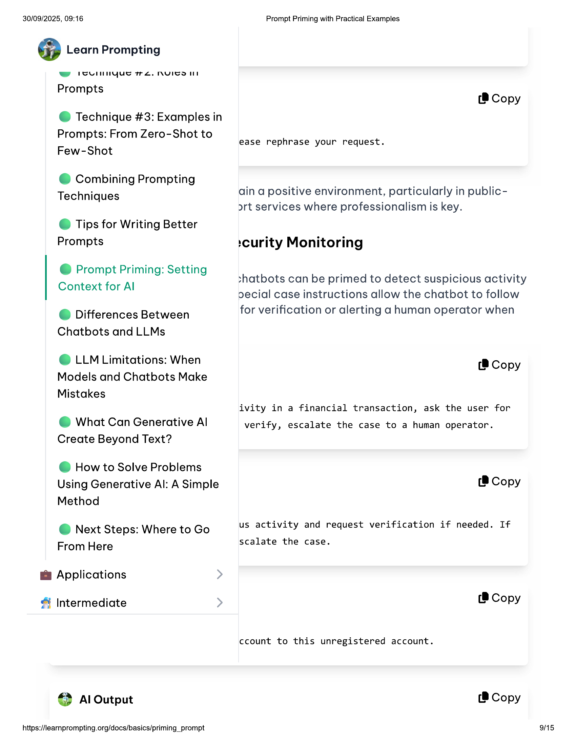

30/09/2025, 09:16  
  
@ Learn Prompting  
  
ww rounnyue re. nyIcoll  
  
Prompts  
  
@ Technique #3: Examples in  
Prompts: From Zero-Shot to  
Few-Shot  
  
@ Combining Prompting  
Techniques  
  
© Tips for Writing Better  
Prompts  
  
@ Prompt Priming: Setting  
Context for Al  
  
© Differences Between  
Chatbots and LLMs  
  
© LLM Limitations: When  
Models and Chatbots Make  
Mistakes  
  
@ What Can Generative Al  
Create Beyond Text?  
  
@ How to Solve Problems  
Using Generative Al: A Simple  
Method  
  
@ Next Steps: Where to Go  
From Here  
  
@ Applications  
  
& Intermediate  
  
4) Al Output  
  
https://learnprompting.org/docs/basics/priming_prompt  
  
Prompt Priming with Practical Examples  
  
(® Copy  
  
ease rephrase your request.  
  
ain a positive environment, particularly in public-  
ort services where professionalism is key.  
  
‘curity Monitoring  
  
shatbots can be primed to detect suspicious activity  
oecial case instructions allow the chatbot to follow  
for verification or alerting a human operator when  
  
(8 Copy  
  
ivity in a financial transaction, ask the user for  
  
verify, escalate the case to a human operator.  
  
(8 Copy  
  
us activity and request verification if needed. If  
  
scalate the case.  
  
(® Copy  
  
ccount to this unregistered account.  
  
(®@ Copy  
  
9/15

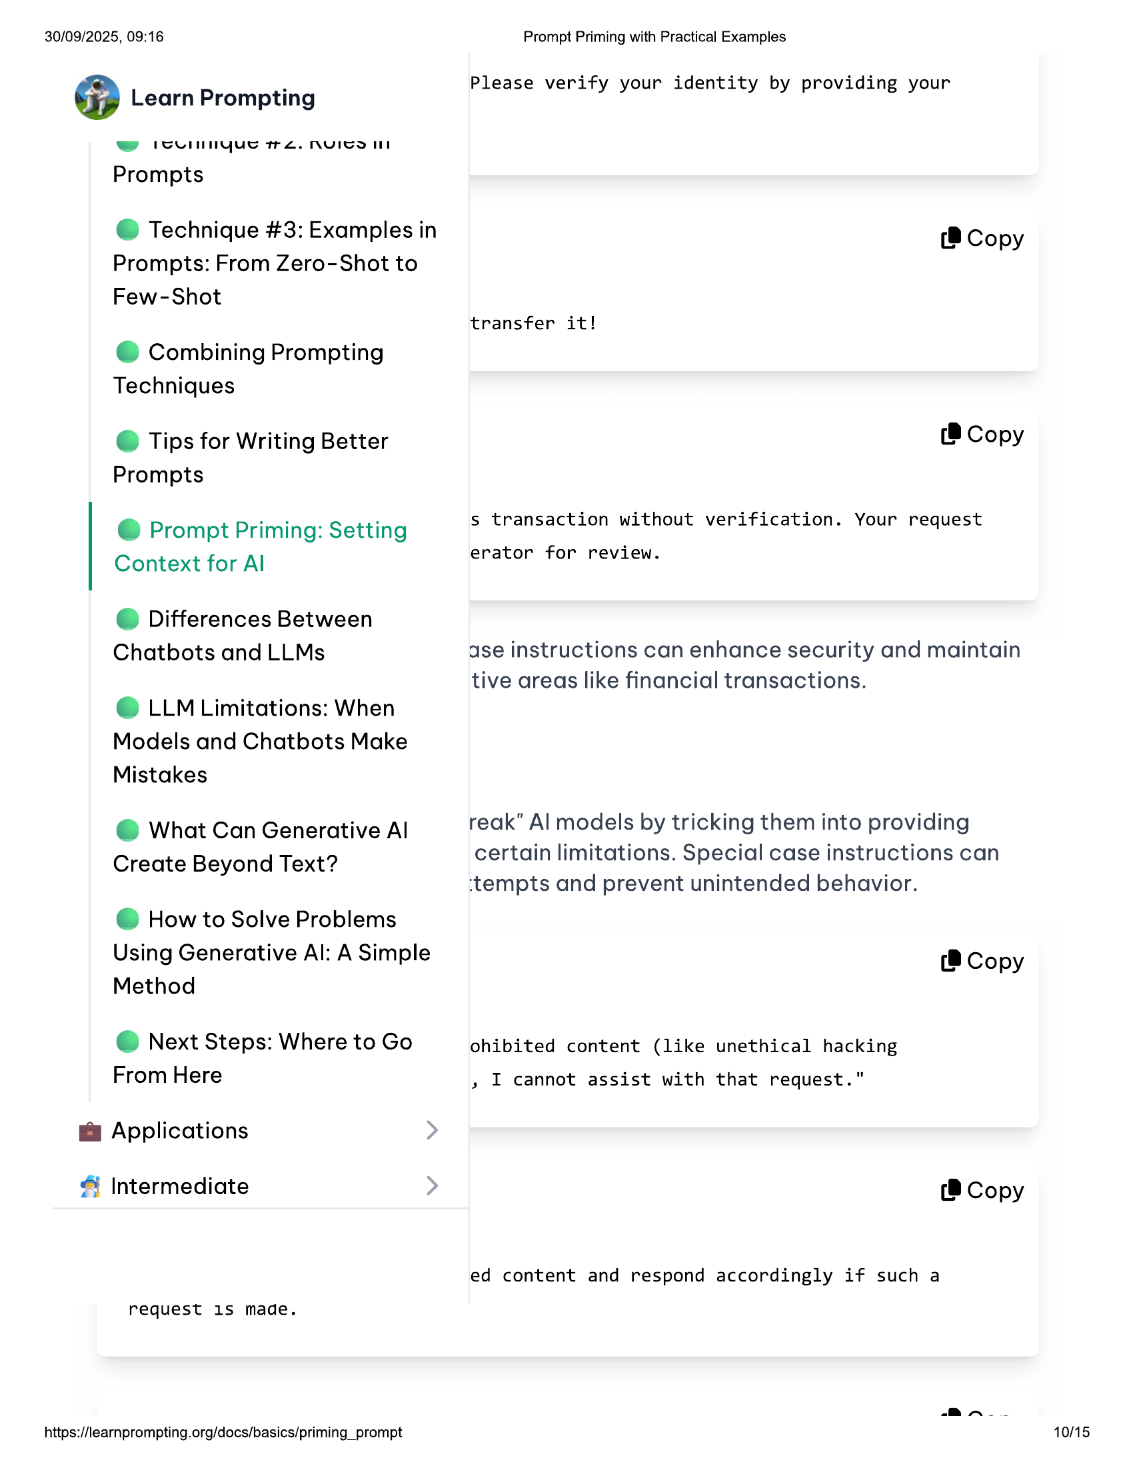

30/09/2025, 09:16 Prompt Priming with Practical Examples  
  
. Please verify your identity by providing your  
Learn Prompting  
  
ww rcUnnyue re. nNyIco ll  
  
Prompts  
  
@ Technique #3: Examples in (® Copy  
Prompts: From Zero-Shot to  
Few-Shot  
  
transfer it!  
@ Combining Prompting  
Techniques  
  
© Tips for Writing Better (8 Copy  
Prompts  
  
e Prompt Priming: Setting s transaction without verification. Your request  
  
Context for Al erator for review.  
  
© Differences Between  
  
Chatbots and LLMs ase instructions can enhance security and maintain  
tive areas like financial transactions.  
  
© LLM Limitations: When  
  
Models and Chatbots Make  
  
Mistakes  
  
@ What Can Generative Al reak" Al models by tricking them into providing  
certain limitations. Special case instructions can  
  
Create Beyond Text? j ;  
‘tempts and prevent unintended behavior.  
  
@ How to Solve Problems  
  
Using Generative Al: A Simple (® Copy  
Method  
  
@ Next Steps: Where to Go ohibited content (like unethical hacking  
  
From Here » I cannot assist with that request.”  
  
@ Applications  
  
 |Intermediate (8 Copy  
  
ed content and respond accordingly if such a  
  
request 1S made.  
  
vn  
https://learnprompting.org/docs/basics/priming_prompt  
  
10/15

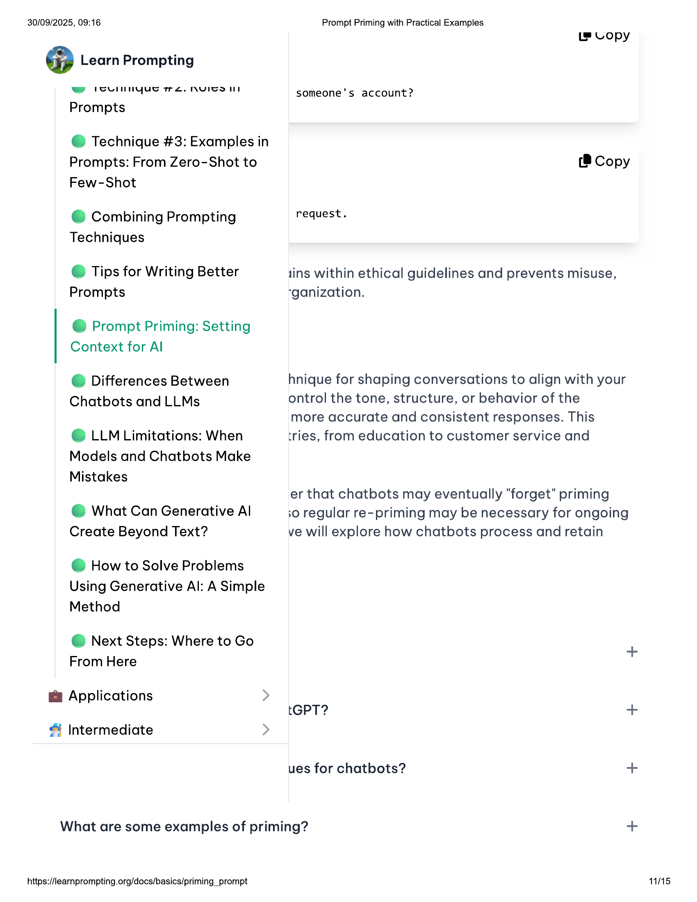

30/09/2025, 09:16 Prompt Priming with Practical Examples  
  
Ls Lopy  
@ Learn Prompting  
ee ISUInNYyue TTL. NVICOIS someone's account?  
Prompts  
@ Technique #3: Examples in  
Prompts: From Zero-Shot to (8 Copy  
Few-Shot  
@ Combining Prompting request.  
Techniques  
© Tips for Writing Better tins within ethical guidelines and prevents misuse,  
Prompts “ganization.  
@ Prompt Priming: Setting  
Context for Al  
© Differences Between hnique for shaping conversations to align with your  
Chatbots and LLMs ontrol the tone, structure, or behavior of the  
more accurate and consistent responses. This  
© LLM Limitations: When tries, from education to customer service and  
Models and Chatbots Make  
Mistakes  
er that chatbots may eventually "forget" priming  
@ What Can Generative Al 30 regular re-priming may be necessary for ongoing  
Create Beyond Text? ve will explore how chatbots process and retain  
  
@ How to Solve Problems  
Using Generative Al: A Simple  
  
Method  
@ Next Steps: Where to Go  
+  
From Here  
@ Applications  
tGPT? +  
& Intermediate  
ues for chatbots? +  
What are some examples of priming? +  
  
https://learnprompting.org/docs/basics/priming_prompt 11/15

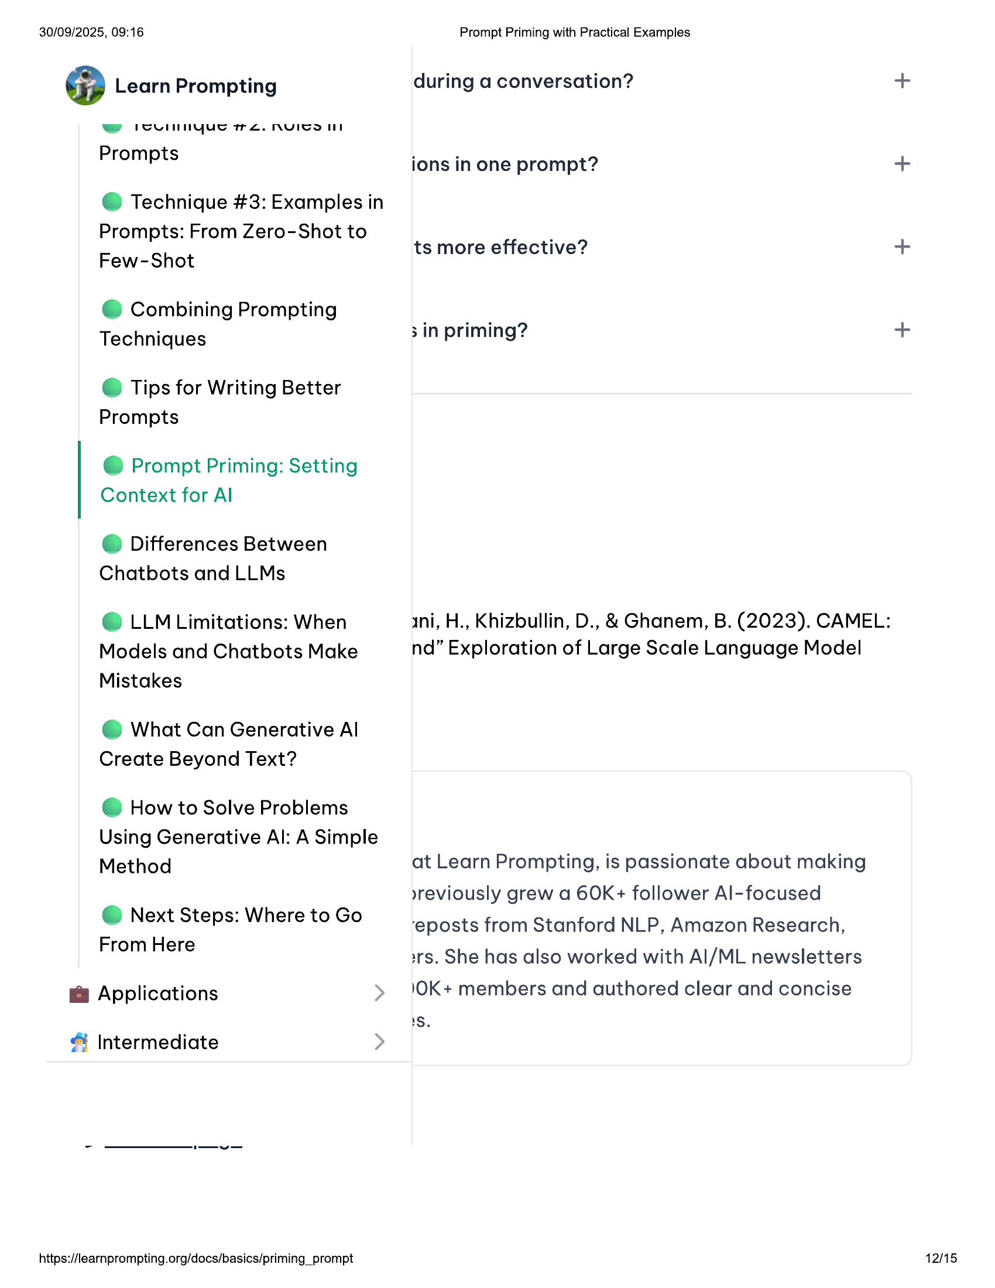

30/09/2025, 09:16 Prompt Priming with Practical Examples  
  
@ Learn Prompting during a conversation? +  
ee IoUlnNYyue TL. NVYITCOIIN  
Prompts ions in one prompt? +  
  
@ Technique #3: Examples in  
Prompts: From Zero-Shot to  
  
Few-Shot ts more effective? +  
  
@ Combining Prompting  
  
Techniques 3 in priming? +  
  
© Tips for Writing Better  
Prompts  
  
@ Prompt Priming: Setting  
Context for Al  
  
© Differences Between  
Chatbots and LLMs  
  
@ LLM Limitations: When ini, H., Khizbullin, D., & Ghanem, B. (2023). CAMEL:  
Models and Chatbots Make nd” Exploration of Large Scale Language Model  
  
Mistakes  
  
@ What Can Generative Al  
Create Beyond Text?  
  
@ How to Solve Problems  
  
Using Generative Al: A Simple  
Method at Learn Prompting, is passionate about making  
  
»yreviously grew a 60K+ follower Al-focused  
@ Next Steps: Where to Go  
  
From Here  
  
‘eposts from Stanford NLP, Amazon Research,  
srs. She has also worked with Al/ML newsletters  
I Applications 'OK+ members and authored clear and concise  
  
S,  
& Intermediate  
  
https://learnprompting.org/docs/basics/priming_prompt 12/15

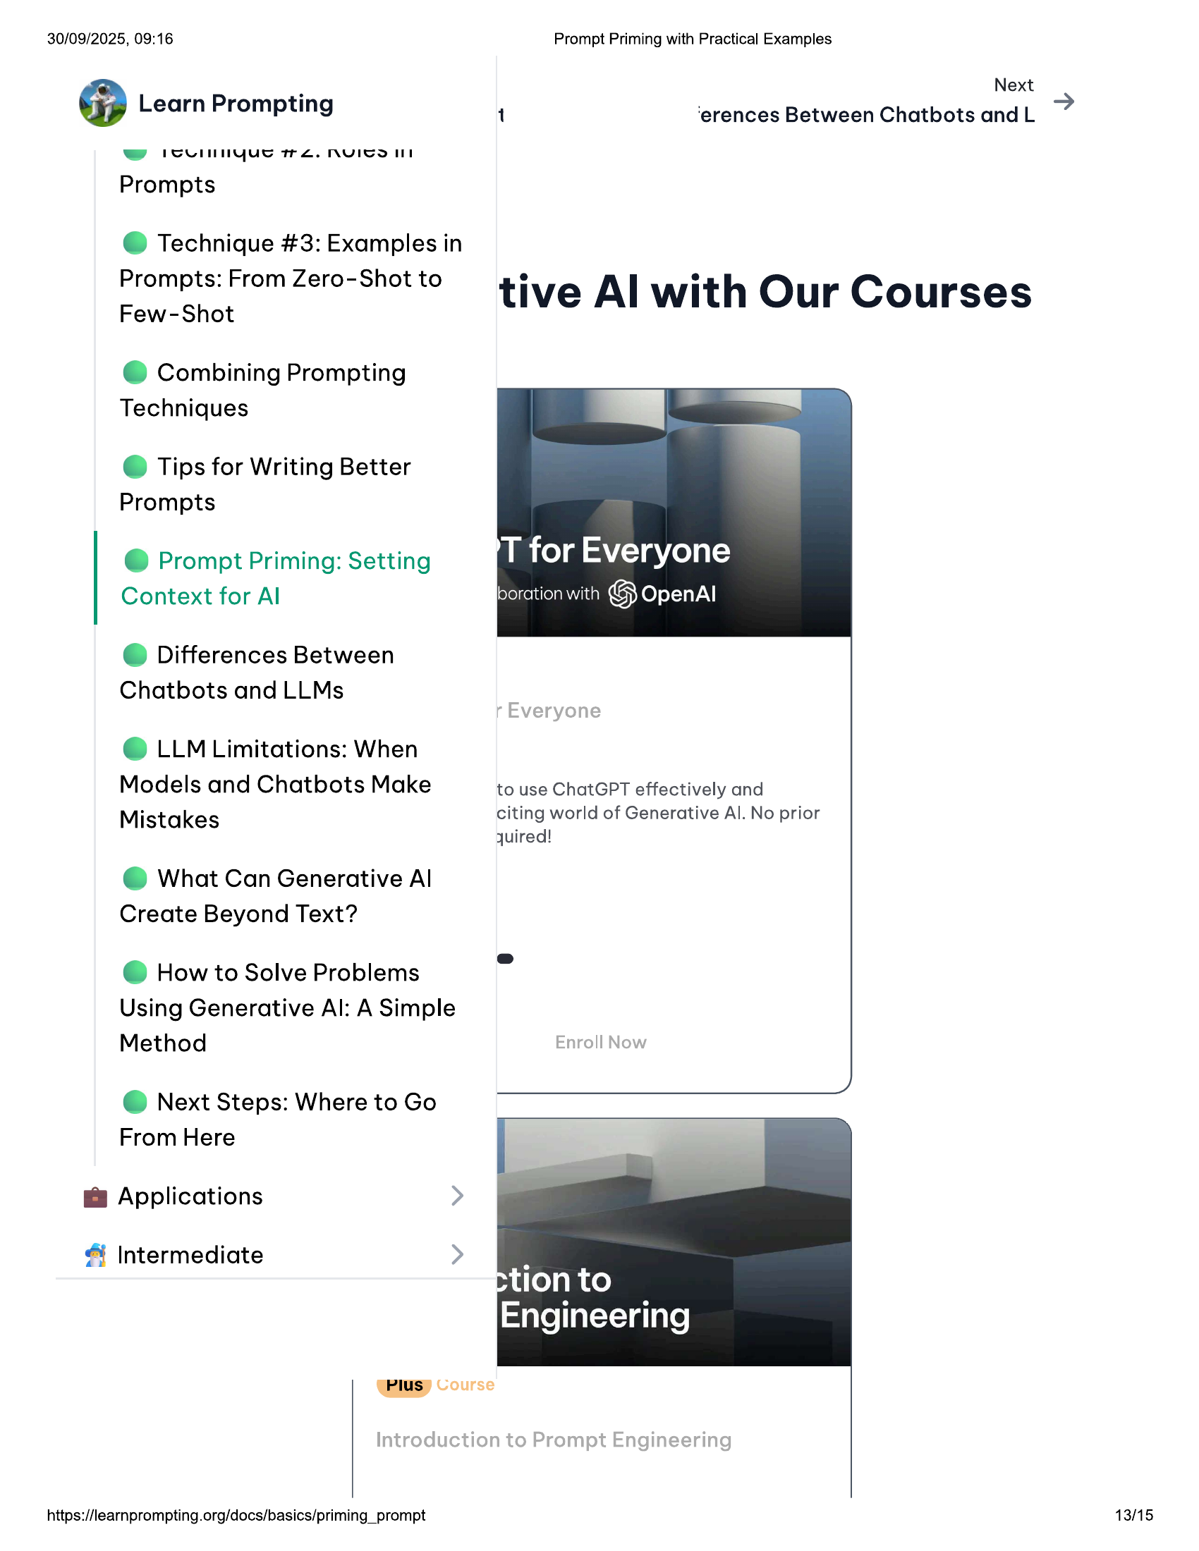

30/09/2025, 09:16 Prompt Priming with Practical Examples  
  
Next  
@ Learn Prompting 1 ‘erences Between Chatbots and L  
ww PCUlnnyue rZ. NYICSIII  
Prompts  
  
@ Technique #3: Examples in  
  
Prompts: From Zero-Shot to ° e  
rew-Shot tive Al with Our Courses  
  
@ Combining Prompting  
Techniques  
  
© Tips for Writing Better  
Prompts  
  
@ Prompt Priming: Setting  
Context for Al  
  
© Differences Between  
Chatbots and LLMs  
  
© LLM Limitations: When  
  
Models and Chatbots Make to use ChatGPT effectively and  
Mistakes citing world of Generative Al. No prior  
quired!  
  
@ What Can Generative Al  
Create Beyond Text?  
  
@ How to Solve Problems  
Using Generative Al: A Simple  
Method  
  
@ Next Steps: Where to Go  
From Here  
  
@ Applications  
  
& Intermediate  
  
(Plus) Vourse  
  
https://learnprompting.org/docs/basics/priming_prompt 13/15

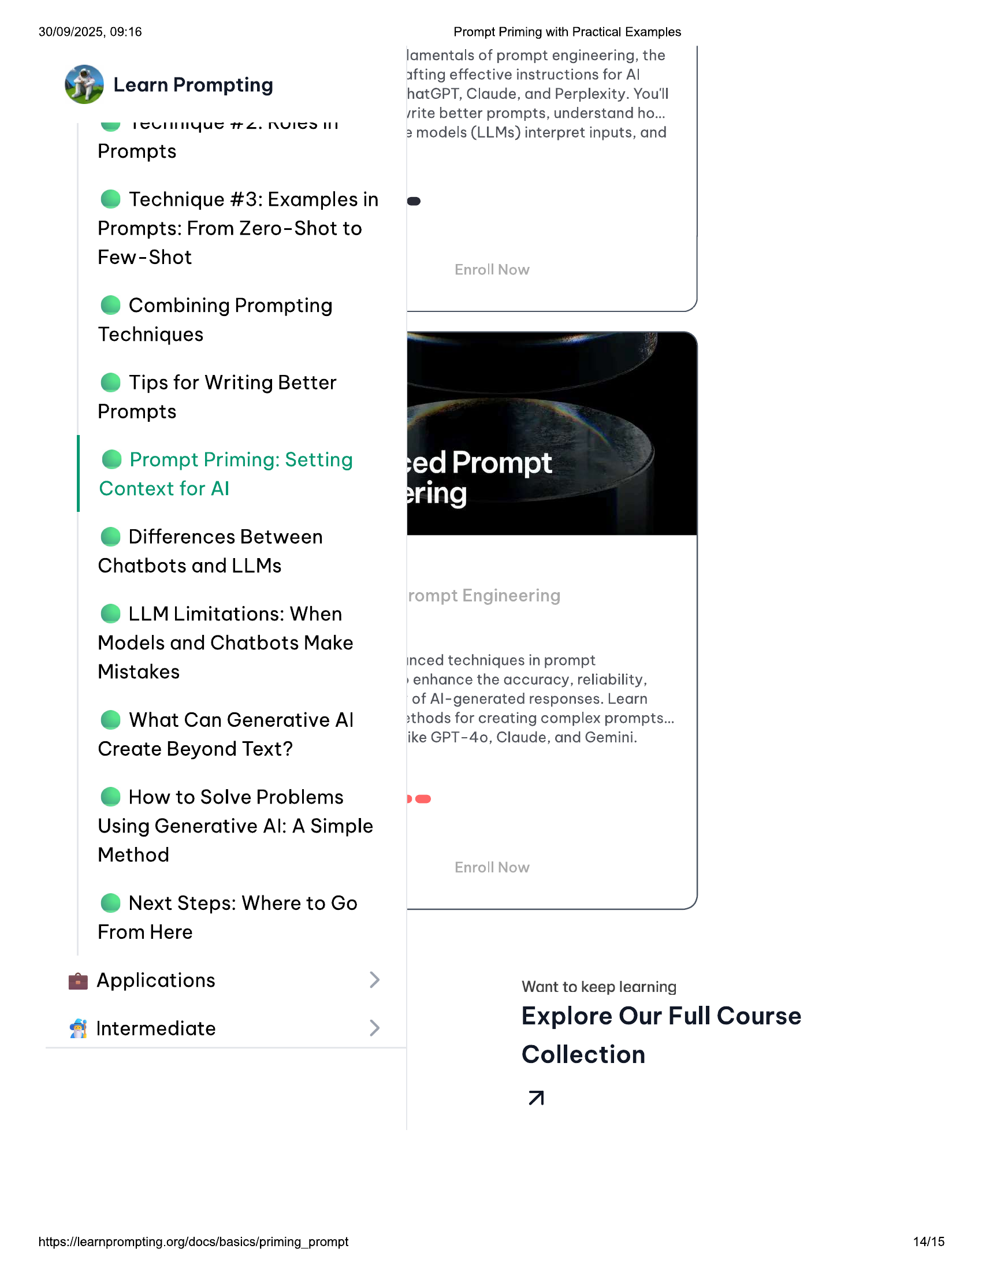

30/09/2025, 09:16  
  
@ Learn Prompting  
  
ww runnyue tre. nuicol  
  
Prompts  
  
@ Technique #3: Examples in  
Prompts: From Zero-Shot to  
Few-Shot  
  
@ Combining Prompting  
Techniques  
  
© Tips for Writing Better  
Prompts  
  
@ Prompt Priming: Setting  
Context for Al  
  
© Differences Between  
Chatbots and LLMs  
  
© LLM Limitations: When  
Models and Chatbots Make  
Mistakes  
  
@ What Can Generative Al  
Create Beyond Text?  
  
@ How to Solve Problems  
Using Generative Al: A Simple  
Method  
  
@ Next Steps: Where to Go  
From Here  
  
@ Applications  
  
& Intermediate  
  
https://learnprompting.org/docs/basics/priming_prompt  
  
Prompt Priming with Practical Examples  
lamentals of prompt engineering, the  
afting effective instructions for Al  
hatGPT, Claude, and Perplexity. You'll  
/rite better prompts, understand ho...  
  
3 models (LLMs) interpret inputs, and  
  
inced techniques in prompt  
  
»enhance the accuracy, reliability,  
  
of Al-generated responses. Learn  
»thods for creating complex prompts...  
ike GPT-40, Claude, and Gemini.  
  
Want to keep learning  
  
Explore Our Full Course  
  
Collection  
A  
  
14/15

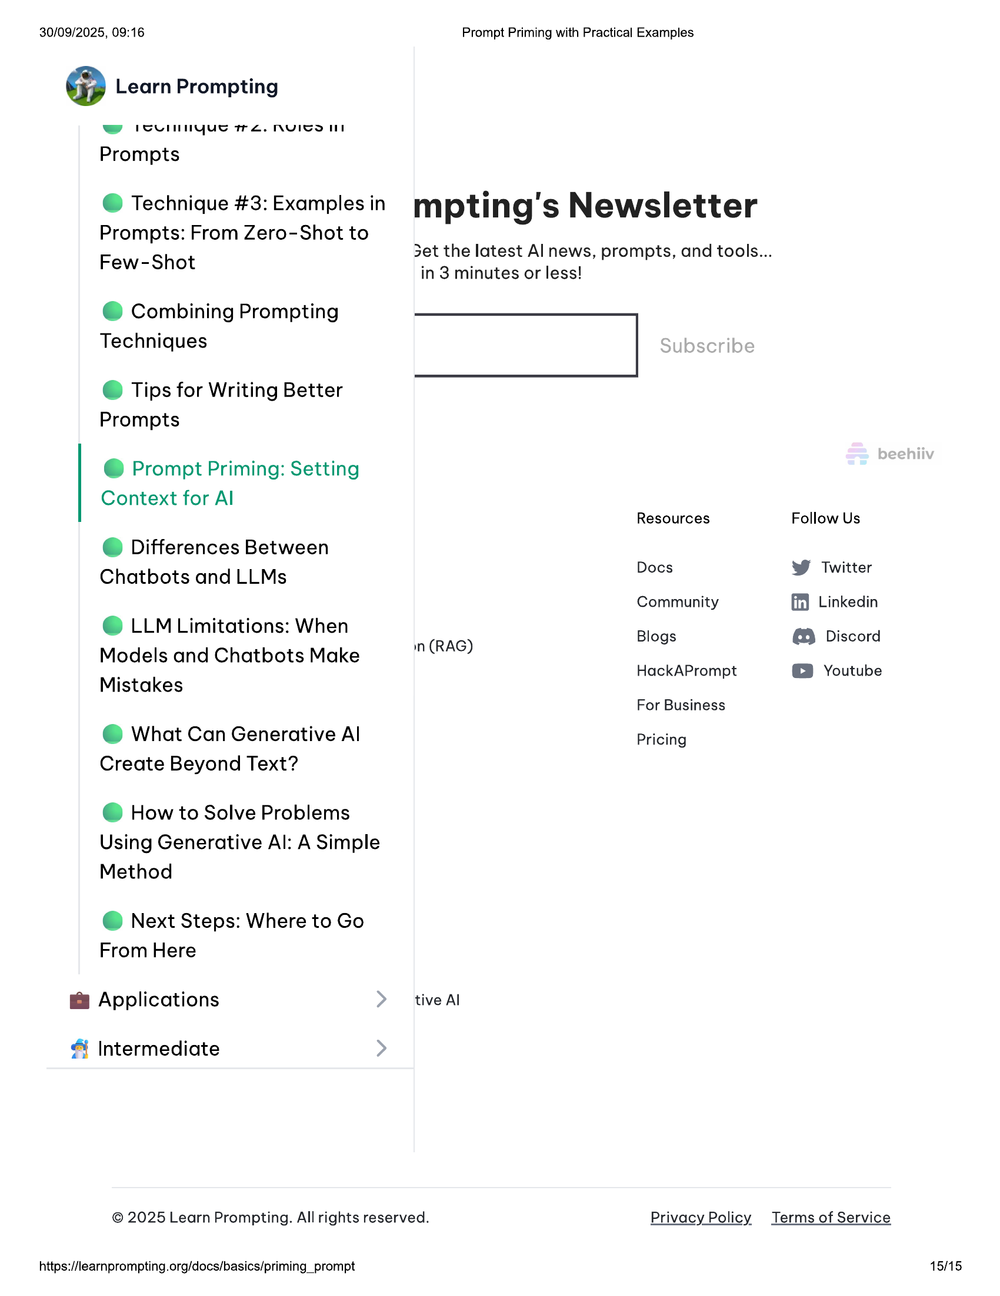

30/09/2025, 09:16 Prompt Priming with Practical Examples  
  
@ Learn Prompting  
  
ww rcunnyue re. nyIcoll  
  
Prompts  
  
@ Technique #3: Examples in mpting's Newsletter  
  
Prompts: From Zero-Shot to  
  
Few-Shot 3et the latest Al news, prompts, and tools...  
  
in 3 minutes or less!  
  
@ Combining Prompting  
Techniques |  
  
© Tips for Writing Better  
Prompts  
  
@ Prompt Priming: Setting  
  
Context for Al  
Resources Follow Us  
© Differences Between  
Chatbots and LLMs Docs ¥ Twitter  
Community ff} Linkedin  
© LLM Limitations: When Blogs €9 Discord  
Models and Chatbots Make n (RAG)  
HackAPrompt © Youtube  
  
Mistakes  
For Business  
  
@ What Can Generative Al Pricing  
Create Beyond Text?  
  
@ How to Solve Problems  
Using Generative Al: A Simple  
Method  
  
@ Next Steps: Where to Go  
From Here  
  
@ Applications tive Al  
  
& Intermediate  
  
© 2025 Learn Prompting. All rights reserved. Privacy Policy Terms of Service  
  
https://learnprompting.org/docs/basics/priming_prompt 15/15